SCERM44 meets Biological Dataset
Acoustics – as per previous outputs
Dolphins – as per previous outputs

Fish Communities
Current model outputs are sites (nearshore offshore) for each year and month.
Going forward with SCERM44 it would be good to have:
Outputs for sites (both nearshore and offshore) that cover three timeseries:
- Year - month
- Sample date range
- Season - summer (Dec-Feb); autumn (Mar - May)
Outputs that focus on the FCI zones and within them shallow (<1.2m) and deep areas (>1.2m) and the same timeseries.
- Year - month
- Sample date range
- Season - summer (Dec-Feb); autumn (Mar - May)

Known dates of fish sampling over spring and autumn were
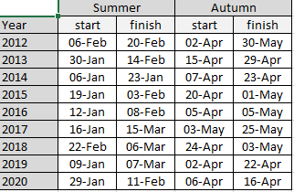

Zones shown in map (note excel spreadsheet provided – Spatial range delineation for biol data V3)
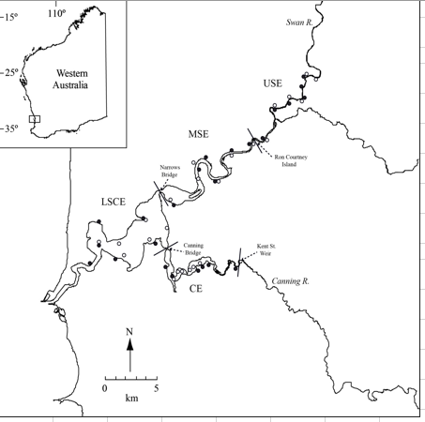
FCI Sites (note excel spreadsheet provided – Spatial range delineation for biol data V3)
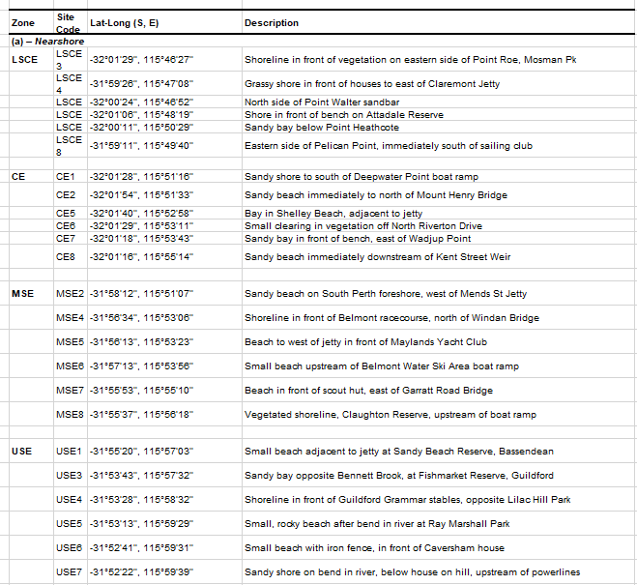
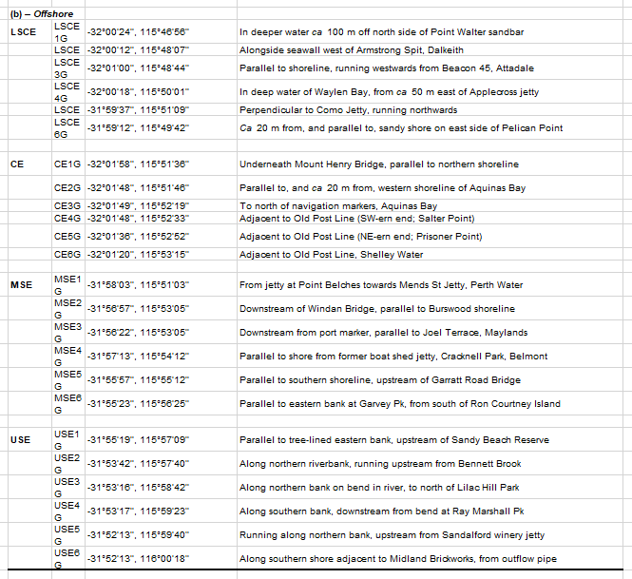

Prawns
Current SCERM8 outputs are sites for each year and month (SCERM8 v1 output)
And sites for specific dates (SCERM8 v3 output). V3 output misses out winter periods where sampling did not occur.

Moving forward with SCERM44:
Information that covers non-sampling periods. Arbitrary date around new moon could be selected.
Zones – shallow / deep

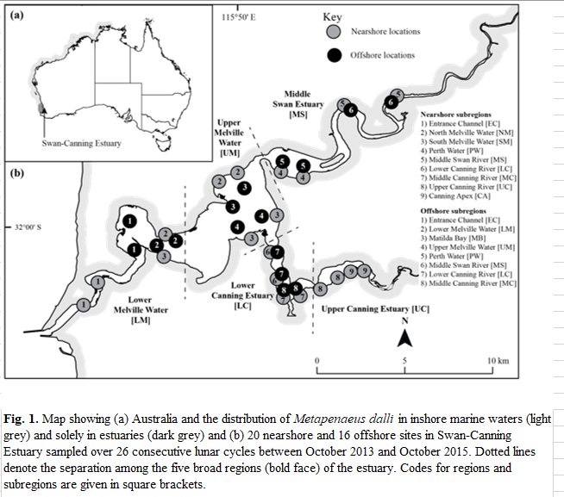
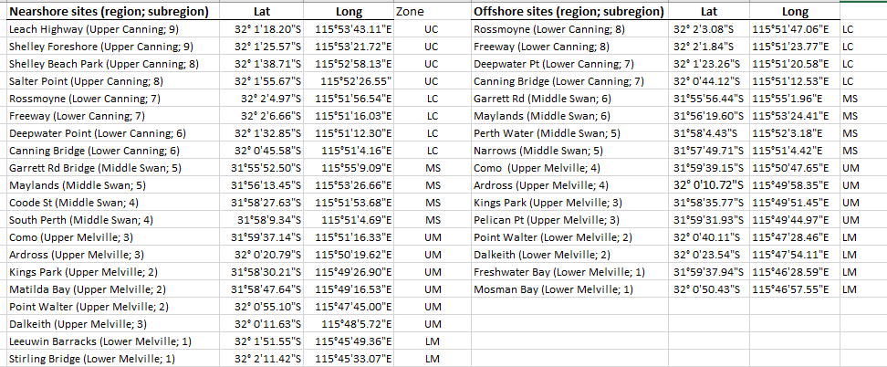

Invertebrates
Current SCERM8 outputs lack shallow site.
Moving forward with SCERM44:
Want shallow (<1.2m shallow and deep data for all sites) and region as whole
Note JC to Reconfigure boundary zones for sites and regional boundary covering all sites
